# C3- S4 PRACTICE

# RANGE OF EXPRESSION

1. Represent the **range** related to the **expression** with a RED color on the line
2. Simplify the expression by removing the redundant conditions

# SQUARE CONDITIONS

Find the boolean expression that match the dark shape (the expression should True if the point of coordinates (x, y) is inside the shape and False if it is outside)

CONDITION 4:

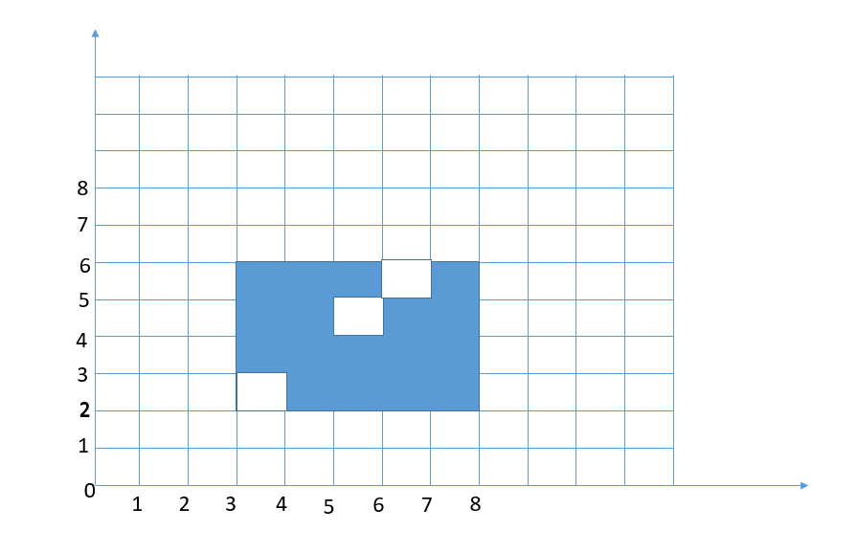

(x>3 and x<8 and(y>2 and y<6) and !(((x>3 and x<4 and y>2 and y<3) and(x>5 and x<6 and (y>4 and y<5) and (x>6 and x<7) and (y>5 and y<6)))

SQUARE-CONDITION 5:

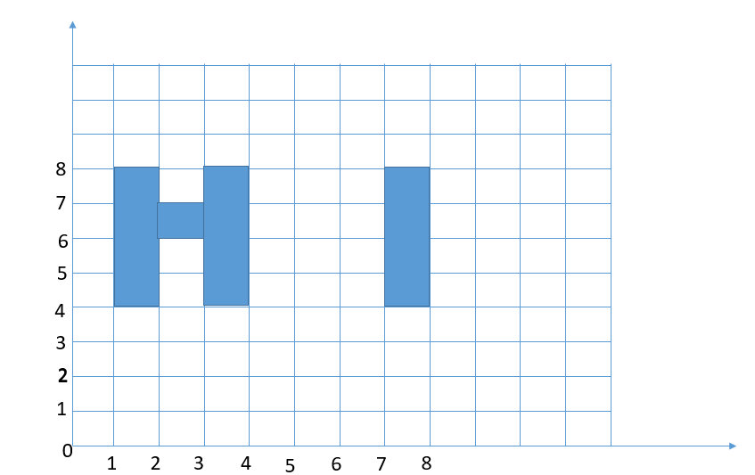

Your answer:

(x >1 and x<2 and y>4 and y<8)or

(x>2 and x<3 and y>6 and y<7) or

(x >3 and x<4 and y>4 and y<8) or (x>7 and x<8 and y>4 and y<8).

SQUARE-CONDITION 6:

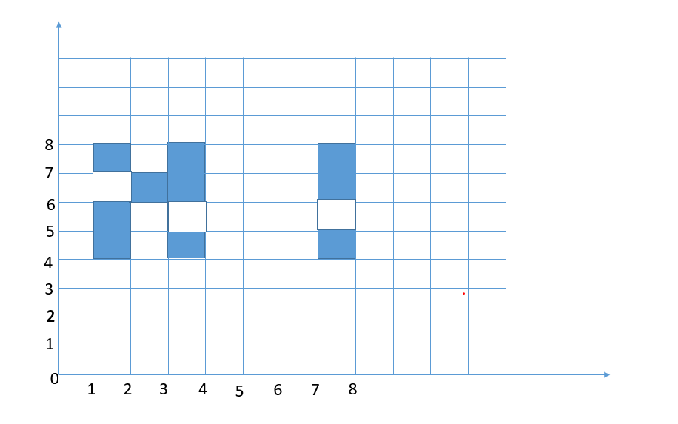

Your answer:

(x >1 and x<2 and y>4 and y<6) or

(x >1 and x<2 and y>7 and y<8) or

(x >2 and x<3 and y>6 and y<7) or

(x >3 and x<4 and y>4 and y<5) or

(x >3 and x<4 and y>6 and y<8) or

(x >7 and x<8 and y>4 and y<5) or

(x >7 and x<8 and y>6 and y<8).

SQUARE-CONDITION 7:

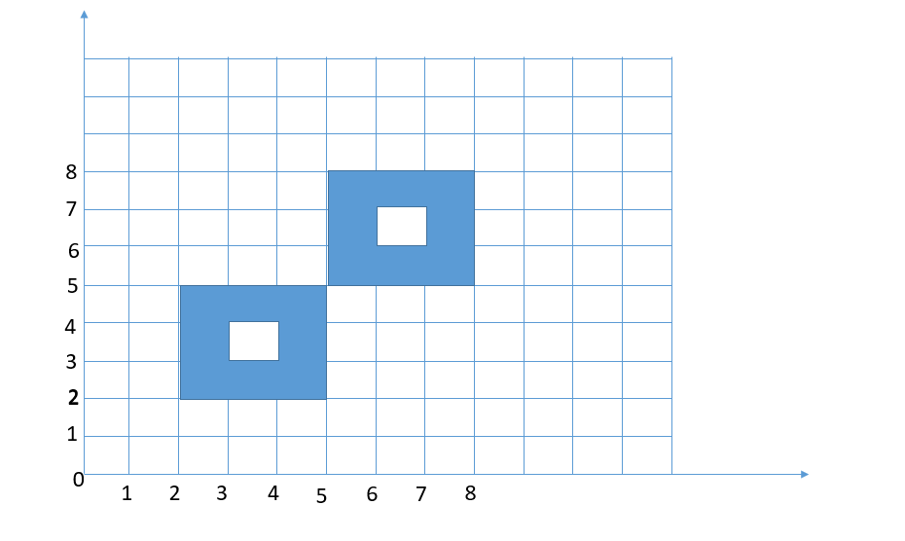

Your answer:

((x >2 and x<5 and y>2 and y<5) or

!(x >3 and x<4 and y>3 and y<4)) or

((x >5 and x<8 and y>5 and y<8) or

!(x >6 and x<7 and y>6 and y<7).

SQUARE-CONDITION 8:

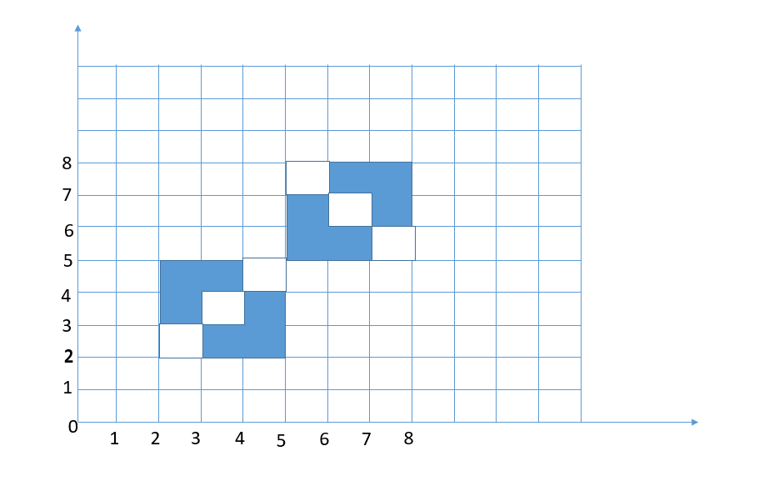

Your answer:

(x >2 and x<5 and y>2 and y<5) or

!(((x >2 and x<3 and y>2 and y<3) or

(x >3 and x<4 and y>3 and y<4) or

(x >4 and x<5 and y>4 and y<5)))or

(x >5 and x<8 and 5>4 and y<8) or

!(((x >7 and x<8 and y>5 and y<6) or

(x >6 and x<7 and y>6 and y<7) or

(x >5 and x<6 and y>7 and y<8).